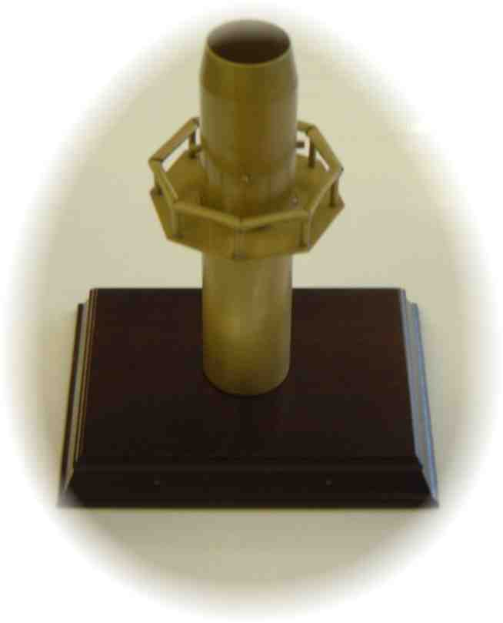
GOLDEN STACK AWARD
The STA “Golden Stack Award” is presented to the process operator who, in the opinion of our members, has made significant efforts to ensure the safety, welfare and comfort of stack testers in the field. It is hoped that this award will act as a driver to improve conditions on site for stack testers.

Qualifying Criteria
Minimum standards of safety, facilities and sampling arrangements are laid down in law or in guidance, such as the Environment Agency’s M1 and our own “yellow booklet”. All process operators should be complying with these as a minimum. Operators not meeting these standards are not eligible for the award.
The award is designed to recognise those operators who have gone the extra mile to protect and assist our members in their work on site, which is often carried out in demanding and uncomfortable conditions.

Nominations
The following aspects of the site/ stack should be considered when nominating an operator:
- Access and facilities;
- Health and safety;
- Accommodation and environment; and
- Management involvement.
STA members are invited to nominate a process operator for this award. It is anticipated that members’ site staff will be active in the choice of nomination. The completed nomination form (attached) should be received by the STA office by 21st April 2017. The award decision will be reached by a vote of the STA elected officers based on the information received, and their decision will be final. All information submitted will be held in the strictest confidence.
The Golden Stack Award will be made during AQE 2015 at the STA Gala Dinner on 24th May 2017, Telford Conference Centre.
Attached is a nomination form, please complete supplying as much information as possible which could include supporting photographs and/or drawings/sketches.

STA Member
Contact
Tel No
Email Address

Process Operator
Contact
Address
Post Code
Tel
Email
Category | Examples of issues you may consider important | Details of why this site should be considered as having gone the extra mile – You may describe as many examples as you wish | Scoring (Judges only)
Access and facilities | - Sampling location in best position to minimise risks to members;  - platform has extra provisions to make work more safe and comfortable;  - ports loosened off;  - CEMs equipment not in the way. | The installation in question ensured there was close involvement with ourselves during the planning stage of the project to ensure that all sampling positions were in the correct positions. The nature of the process meant that in order to comply with the requirements of Environment Agency note M2, significant work was required to accommodate the large sampling probes that would be required.  This resulted in construction to extend platforms that enabled us to carry out the work in a manner that we feel can be done to the highest standard.  Due to the nature of the process, there are corrosive gases present which results in ports often being seized. To ensure the site work progresses satisfactorily, Rockwool ensure that where required maintenance personnel release any difficult ports prior to sampling.  The particular stack that has been highlighted as part of this nomination had CEMS fitted away from our monitoring points, but where gaseous monitoring is required suitable ports have been installed adjacent to the CEMS. Several of the monitoring points have areas that can be utilised for shelter, that enable our personnel to work out of the elements. We have also been in discussions about installing additional shelters on the high platform to offer additional cover in the event of adverse weather. There is currently availability within the stack, but additional area would give our staff a better environment.
Health and safety | - Inspection records of platform. | As a multinational organisation, health and safety is of paramount importance, with continuous monitoring of all aspects of our work and work conditions. At present, Rockwool carry our routine inspections as part of a preventative maintenance programme, and have also identified additional steps for improvement to this system that are planned to be introduced during this year.  During initial stages of construction of the new line, there was talk of having vertical ladder sections to climb up to the sampling point. We had various meetings with our contacts on site, after which it was agreed that at an additional expense to Rockwool, a staircase was going to be installed as this was considered a safer approach for all parties.  Rockwool also enlisted the help of specialist lifting companies to ensure a suitable hoist was installed that enabled our equipment to be hoisted safely.
Accommodation and environment | - Cleanliness of working environment;  - wash and rest area;  - water and refreshments. | The work areas are routinely cleaned by Rockwool personnel, and we have all hygiene facilities on hand for our use. There are also many drinks dispensers on site that our personnel have access to.
Management involvement | - Co-operative attitude, helpfulness and positive attitude towards site staff;  - provision of necessary information | All members of staff that we deal with at Rockwool cannot do enough to assist us in any way they can and are always available if our personnel need anything. The Rockwool personnel are always very efficient in supplying us with any information that we require and always go out of their way to ensure we have everything we need to complete the work.
Scoring:

Other factors to be taken into consideration.

